Drew Cochran

02FEB2023

Course: Python Fundamentals

Assignment 04

**Strings, Tuples, and Lists, with Tables**

**Introduction**

This is the fourth assignment for the Python Fundamentals course. The overall course is looking well, and I am excited to get started and learn more about Python and practice my coding and build upon my limited skills in Python. I continued to be excited about this one as we were writing to a text file as well as displaying inputted data as requested by a user.

**Pseudo-Code**

I was determined to use pseudo-code this assignment, and I did write some out. See my pseudo-code document for what I did. I know I need more refinement, perhaps less detail too, though I was trying to show myself, and others, where I was thinking of going and why.

**Collections and Strings**

This was a review of previous knowledge I had of these two topics, with the looping a great refresher. One thing I was struggling with is printing to one line, such as in Lab 4-1. Randal helped out with that looping, which was great and grew my knowledge of how to do it. Course I need more practice, but it is a great start again for me.

**Tuples**

Tuples I have always loved since the data is immutable. Of course, it means I can only add to the tuple and have to convert if I ever want to change it, but, to me, it feels so secure. Something I was not truly aware of was how to unpack tuples easily, such as assigning each piece of the tuple to a variable to either display or write somewhere. This sounds perfect in how to iterate through a series of tuples. Equating it to a table was good, too, as that is something that, while I instinctively may have understood, never thought about when it came to the data in lists and tuples, perhaps dictionaries too.

**Watching the video**

Randal’s video was again informative and helpful to me. I still enjoy how detailed the video gets without being boring or going off track. Many times, watching other videos, I find myself falling asleep. I used Visual Studio Code again to follow along on the examples, which let me get some reps in. I like how VSC works, as well as PyCharm, and how VSC has so many modules for other languages to import and use that I want to continue using it and practicing.

**Script Assignment**

The assignment was to create a script file in Python allowing a user to input to points of data, a household item’s name, and it’s value, in monetary terms. The script then writes that data to a .txt file in a set location (I chose the location in the assignment screenshot, though I know I could have it written in the same location as the program is run), then closes the file and the program.

I saw this and envisaged the code fairly quickly, and I wrote it in one go. I changed it up a bit, too, to keep the program open with a while loop until the user typed “exit” and pressed enter. I got the correct result, but in my output I saw the word “None” on the line below the statement “Enter a Item” and “Enter an Estimated Value.” See Figure 1.1 for the error.

Figure 1.1 “None” Error

I immediately started looking around for the problem, but I couldn’t see it, so I saved till the next day. After further thinking, I resorted to Stack Overflow and other online resources, even going so far as to posting the question myself. Turns out I couldn’t see the issue even though it was right in front of me. Many people have also encountered what I did, which was embedding a print() function inside the output() function. Every time, the print() returns “None” since there isn’t any values or strings to print out, so Python dutifully returns “None” on the screen. Feel silly for such a simple mistake, but it happens, and I learned a lesson, another win in my book.

As for the rest of the code, there wasn’t any issues, and the text file gets appended correctly every time the code runs, and the code stays open correctly until the user enters “exit” of any flavor due to the lower() function. One thing I would have like to due in future is input column and row headers to nest the household items under, making it easier for the user to read. Something I will try in future. See Figure 1.2 for my code.

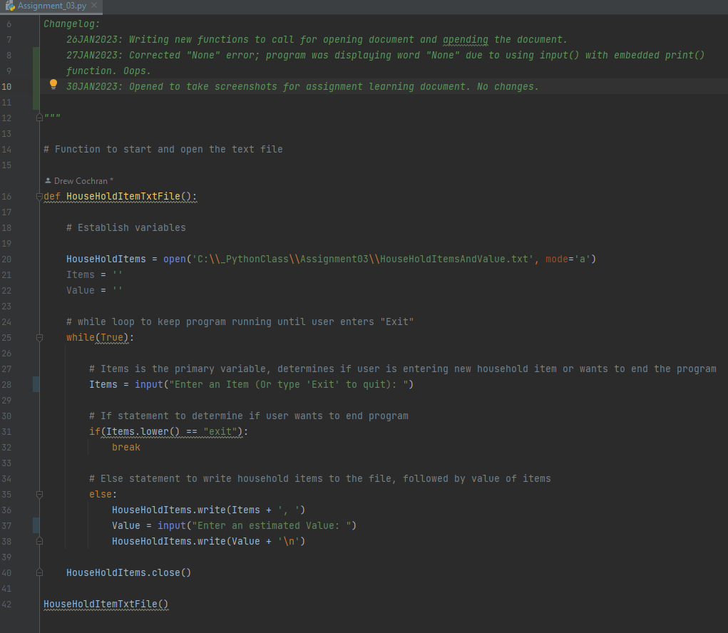

Figure 1.2 Household Items Code

**Conclusion**

I enjoyed this second assignment. Even though it was not much of a challenge for me, I know the challenges are going to be there. I plan on going over the fourth assignment tonight (Monday) as I have vacation coming up and still want to get ahead. I am enjoying my learning and the feedback I am getting. Thank you and keep it coming!